

October 31, 2025

To: Fordham Team
From: Terri Matthews and Will Hsiao
Re: Data Analysis Going Forward

1. Both Infra and PB teams should be doing the same things listed below. At some point as noted below there will be differences, but basic rule is same thing for both teams. The team effort applies to the common research plan for Infra and for PB and the corresponding data visuals.
2. The top line indicators from which to create variables the analysis are below. You cannot do most of the analyses you suggested doing until you create new variables from these indicators:
Budget
Schedule

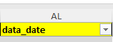
3. There is a Data Dictionary for these top line indicators in the Open Data. Each column of all 4 datasets has their definition and explanation in the 2nd tab of the data dictionary. When you write your final report, it will be important to use the definition/explanation of the indicators used on this project. Suggest putting that in an appendix to the final report.
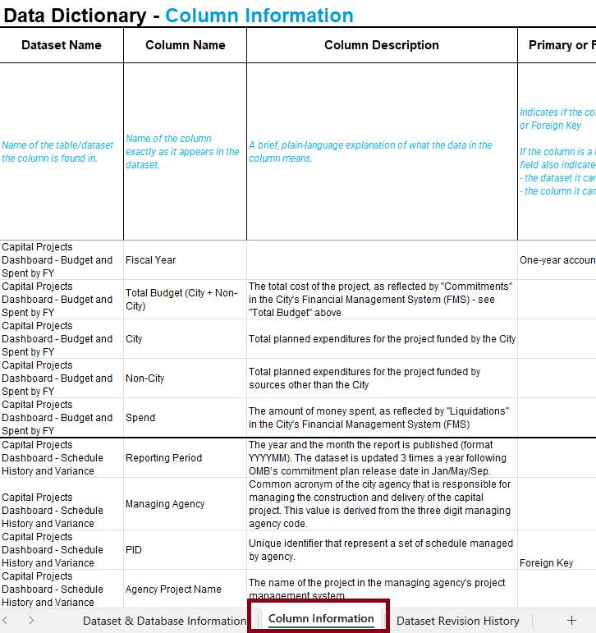
4. Suggestions for variables to create and when you write your final report you need to describe this process. This step needs to be done by both teams in their data sets, before regression analysis and other data analytics from your ideas can be done.
A. I was thinking that for each project:
- Spend to Date (T)/Total Budget(S) for each project, which could be compared to Budget Variance (V)
AS DISCUSSED ON FRIDAY, there is already a data indicator that calculates the “spend to date %”. This needs to be imported into the two spreadsheets from one of the existing open data data sets. This was discussed at the meeting if you have issues, please contact Will for this one and copy me.

- Working with the Actuals on the schedule side

  - With Actual design start and Actual design end (AA and AB) you can create a variable for the Design Phase Duration; which can then be further analyzed for percentage change between periods and average percentage change, with the average percentage change becoming a new variable: Design Phase Duration Average Percentage Change.
  - With Actual construction procurement start and Actual construction procurement end (AC and AD), you can create a variable for the Construction Procurement Phase Duration, which can then be further analyzed for percentage change between periods and average percentage change, with with the average percentage change becoming a new variable: Construction Procurement Phase Duration Average Percentage Change
  - With Actual construction start and Actual construction end (AE and AF), you can create a variable for the Construction Phase Duration; which can then be further analyzed for percentage change and average percentage change, with the average percentage change becoming a new variable: Construction Phase Duration Average Percentage Change.
  - AS DISCUSSED ON FRIDAY. To create a variable appoximating Total Project Duration, Z is Forecast Completion date and AA is Actual design start—the only indicator in the data set that shows the beginning of a project, so AA Actual design start – Z Forecast Completion date becomes the Total Project Duration variable. As above, this variable can then be further analyzed for percentage change and average percentage change, with the average percentage change becoming a new variable: Total Project Duration Average Percentage Change.

- Other: each reason for delay should be treated as variables for regression and other analyses.

Note 1: Since there is only 2-1/2 years of reported data, you may not be able to create new variables for all projects, which will limit some of the findings from analysis. That will have to be a caveat But the methodology is what people after you can use and IF THERE IS TIME, it can be done for the completed projects >$25 M for which the 2013 system data has.
Note 2: These defined new variable terms in yellow are important for both teams to use because, after years of working with this kind of data, “duration” is a term that the design and construction professionals hearing your presentation and reading your final report will understand.
B. Will has suggested-if you have questions on these plus the new one below, please contact Will:
- Average schedule delay (days) between period-to-period by sponsor agency
- Average budget change (dollars and percentage) between period-to-period and year-to-year by sponsor agency
- Since our dataset has many completed projects. Most of the completed projects has full set of actual milestone dates from design start to construction end. What about an analysis over actual phases duration (days) vs actual spent ($)? This might get a correlation between money spent and construction duration (does spending more money always takes longer)? This can also be made a heat map with actual spend on x-axis and construction duration (or total duration) on y-axis, by PB/Infra or agencies.

These may be created from some of the work above.
5. Ongoing Data Viz must be done for these along the lines of the initial Data Viz exercise.
6. Student Ideas: TG comments in blue
Please remember that both teams need to do most of these ideas for both data sets. You may want to meet together to decide which ones are common to both data sets and do them in an organized fashion simultaneously producing data viz for each of them. What I am seeing is a lot of good independent thinking but you need to think this through together for the project. You are 2 teams.
1. PREDICTIVE ANALYSIS OF PROJECT DELAYS AND BUDGET OVERRUNS
We could use historical project characteristics (e.g., managing agency, borough, project type, estimated duration, and total cost) to build a model that predicts the likelihood of delay or cost overrun. This would help identify early indicators of high-risk projects.
- Techniques: Logistic regression or random forest for classification
- Possible insights: Which agencies or project categories have the highest probability of delay? Which factors contribute most to cost variance?
Thoughts—regression and predictive analyses are good to do—prior Fordham students have done that—but they will be constrained by the variables you can create from the data set as described above.
2. Reason for Delay Analysis
This came up from the Public Building team. Reason for Delay Analyses should be done by each team for their data set. The top reasons for delay will vary by Infra or PB
While reviewing our dataset, I noticed that the top reason for delay is “PROJECT DELAYED DUE TO CHANGES IN SCOPE/DESIGN.”
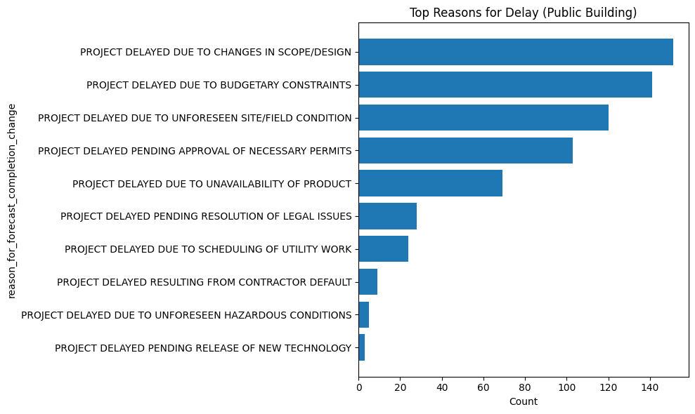
I’m curious to explore:
- Which types of buildings are most affected by scope/design changes (schools, libraries, or public offices)? On the PB side, you can translate the Project Sponsor into a project typology (we discussed this very early on and need to come back to that—I don’t think there is enough time to break down project typology further for this project) See # X on the Infra side.
- Where these delays happen most often (Manhattan, Bronx, etc.)? For this identifying the population density for each borough will allow you to tie this quantitatively to population density. Wikepedia has pop density figures for each of the boroughs that you can use.
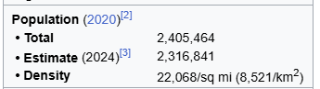

- Whether these projects tend to be over budget or have lower percent completion compared to others?
Not sure what variables you would use for this, but if you can create them and they make sense (a discussion about that would be good) this is fine. Also remember the problem of 2/1/2 years of data
- And which agencies have the highest rate of this kind of delay? Sponsor agency as a proxy for project typology would be the way to rephase this.
I also want to understand the broader context behind these delays.
Sometimes, design changes might reflect new policies, leadership transitions, or changing community needs — things that aren’t captured directly in the dataset but can strongly influence project timelines. My goal is to see whether “design or scope change” delays point to a systemic planning challenge rather than just construction inefficiency. Once you do the delay category analyses, we can discuss what they might mean. See last Fordham report on this.
3/ Group of 3 ideas
1) We could examine whether self-managed agencies complete projects more efficiently. In the analysis I created in the Excel file, I categorized projects to identify how many and which agencies manage their own projects. Using that indicator, we could combine additional variables such as the number of reporting periods and the current project phase to assess performance. We could also analyze the time it takes for projects to move through key stages (Pre-Design - Design - Procurement - Construction - Close-out) to determine whether self-managed agencies progress faster, or if having a separate managing agency introduces delays within the project lifecycle.
In the 10/13 email as repeated in email earlier today— 1. By sponsoring agencies, descriptive stats and data viz on:

- managing agencies and percentage of sponsor agency project done by each managing agency, with agency managed projects as the last category. Like for the xx [sponsor agency] projects, aa (a%) managed by AA managing agency, bb (b%) managed by BB managing agency, cc (c%) managed by CC managing agency, and dd (d%) managed by sponsor agency xx. For some agencies there could be up to 3 managing agencies. Some agencies do not do their own work at all.
The managing agencies typically get the more complex projects, so more complex possible means more delays, more overruns. But this is an area for analysis.
2) Another potential area of analysis that could be examined is the time it takes for projects to progress through the main lifecycle phases (Pre-Design - Design - Procurement - Construction - Close-out) and whether this varies by managing agency. Using indicators such as the reporting period, current phase, and managing agency, we could calculate the average duration projects spend in each phase, and potentially look at what the reasons for the delays are. (Is it consistent amongst certain agencies? Is it consistent amongst boroughs? etc.)
See suggested variables above. This can be done with them with the caveat that we only have 2-1/2 years of data. Showing how it can be done with this time limited data set is valuable.
3) Another potential point is that we could analyze how the distribution of project phases varies across boroughs to identify potential discrepancies amongst the boroughs and if it is a consistent occurrence. By using indicators such as borough, current phase, and reporting period, we can compare the number of projects in each phase (Pre-Design - Design - Procurement - Construction - Close-out) within every borough. This would allow us to see whether certain areas, such as Staten Island, have a higher concentration of projects still in early stages, potentially showing uneven development across the city. YES!
4/ Investigate if higher-budget projects tend to face longer completion times or delays.
Example Question: Does more money actually mean faster completion, or do big projects encounter more bureaucracy and delays?
Methods: Correlation analysis between project budget and duration (start vs. completion dates).
This is another way of getting at idea in 3 (1) above. This is a good correlation analysis to do.
5/ I've been reviewing the dataset and the Primer to better understand how these projects move through the City’s design–bid–build process. After conducting an initial descriptive analysis, I've identified a few patterns — including wide variations in project durations and spending progress across reporting periods — that point to interesting directions for deeper analysis.
Based on that exploration, I'd like to propose the following two potential problem statements to guide our next phase of work:
- Early Indicators of Schedule Delays in Public Building Projects
Goal: Identify which project characteristics (e.g., phase, managing/sponsor agency, borough, building type, or early forecast changes) are most associated with later schedule delays.
Why it matters: Understanding early signals of schedule slippage could help agencies anticipate risk and allocate oversight more effectively. Yes but thinking probably work with Reasons for Delay because I don’t think we can create delay variables from the data. The forecase change indicator for 2-1/2 years of data may not work for this.
- Budget Utilization Patterns Across Boroughs and Project Categories
Goal: Examine how spending progresses over time across different boroughs and building types, using each project’s multiple reporting periods to identify spending curves or bottlenecks. Schedule and budget are chicken and egg. Again issue with 2-1/2 years of data I think.
Why it matters: This analysis could highlight disparities in budget execution pace and help inform more equitable and efficient capital planning. This is an excellent idea but it seems out of scope for this project unless you can show a definite pathway to do this. Capital planning which takes place before budget adoption (and creation of FMSIDs), and that is a separate thing on its own. We can discuss planning (or look at Primer) but think this aspect is our of scope with current state of data.
6/ Another group of ideas
1. Which Sponsor Agencies manage the most projects? This will give us information on the departments having the highest workload. This is supposed to be done for first data viz.
2. What is the average project duration by agency? See variable creation above.
3. Which boroughs have the highest total budget and the highest project count? We can use maps for this to represent it graphically. Yes—see 3 (2) above
4. Which projects are delayed? We can list them by agencies. Reason for delay analysis can provide that
5. Which projects are over the actual budget? Not sure 2-1/2 years of data can show that now.
6. What percentage of the projects are delayed and what percentage are completed on time? Not sure 2-1/2 years of data can show that now.
7. How has spending changed over the years? (We can do this by performing a time series trend analysis). See the variable Spend to Date (T)/Total Budget(S) above ror that
8. Which agencies have the highest financial inefficiencies? Think out of scope with this data set---has been tried before with a richer agency data set with prior Fordham students and wasn’t sure it resulting in actionable findings.

For predictive analysis, I had two ideas:
1. To predict whether a project will be delayed or not. We can try out a classification and see which factors influence more delay? Yes can be done
2. To predict which projects are at a higher risk of exceeding their budget. Only problem at the moment with that is the limitation of 2-1/2 years of data and not sure the variables you can create can do that. Better to focus on higher risk of delay via Reasons for Delay and connect with idea that delay can often lead to increased costs.
I also had a doubt regarding the dataset - Is there any way to classify the project type in infrastructure? For example - Roads, Bridges, Tunnels etc
For Infra we can talk about how to create proxies for project typology in that data set—a little different than PB, but possible. Can discuss.
7/ My idea is to look at what causes project delays and cost overruns in the Capital Project dataset. See references to the Reasons for Delay analyses above.
I’ll check if things like budget size, spend-to-date %, project phase, or agency affect how long projects take or how much they go over budget. I’ll use basic stats, correlations, and simple visuals to find patterns. T related comments above.
8/ Here are a few ideas that came to mind while working with the dataset:
- Project Delay vs. Budget Analysis – Examine whether projects with larger budgets tend to experience longer delays or remain in earlier phases longer than smaller ones. See above for discussion of this in the other ideas.
- Geospatial Investment Pattern – Map total spending by borough to identify if certain areas consistently receive more capital investment for either infrastructure or public building projects. Yes—see above. This is good idea.
- Agency Efficiency Index – Create an index combining budget size, number of reporting periods, and project phase to rank sponsor agencies on efficiency in delivering projects. Not sure if can be done with 2-1/2 years of data to make definitive findings but the approach is something that could be done.

